**Containment zone Alerting Application**

***Batch: B1-1M3E***

***Team ID: PNT2022TMID18635***

***Team:***

1)R.Gowtham(Team Lead)  
  
2)V.S.Mohanaraman  
  
3)C.JayaSurya  
  
4)R.Gobikrishnan

**Introduction:**

***Project Overview***

* This application is intended to provide information about containment zones in a particular region by alerting people, through continuous monitoring of an individual's location.  Key benefits of the application are monitoring people's activity and alerting them of their safety movements.

* The app should have a user registration and login. After the user logged into the app it will track the user's location and update the database with the current location. If the user is visiting the containment zone he will get an alert notification.

* The containment zone will be defined based on: Containment Zones are delineated based on Mapping of cases and contacts, Geographical dispersion of cases and contacts, Area having well demarcated perimeter, Enforceability of perimeter control.A dedicated helpline number will be established at Central, State and District level. Itsnumber will be widely circulated for providing general population with information.

***Purpose*** ***:***

* This project is intended to provide information about containment zones in a particular region by alerting people, through continuous monitoring of an individual's location. Key benefits of the application are monitoring people's activity and alerting them of their safety movements.

* They should login to the app and update the containment zones locations in the

            portal. Based on the location a Geofence will be created within a 100 meters

            radius. They should be able to see how many people are visiting that zone.

* A dedicated helpline number will be established at Central, State and District level. Its number will be widely circulated for providing general population with information on risks of COVID-19 transmission, the preventive measures required and the need for prompt reporting to health facilities, availability of essential services and administrative orders on perimeter control.

***Activities to be undertaken in the Containment zone includes:***

i. Active search for cases through physical house to house surveillance by Special

Teamsformed for the purpose

ii. Testing of all cases as per sampling guidelines

iii. Contact tracing

iv. Identification of local community volunteers to help in surveillance, contact

***Literature Survey*** ***:***

**Existing Problem**

* The recent outbreak of COVID-19 has taken the world by surprise, forcing lockdowns and straining public health care systems. COVID-19 is known to be a highly infectious virus, and infected individuals do not initially exhibit symptoms, while some remain asymptomatic. Thus, a non-negligible fraction of the population can, at any given time, be a hidden source of transmissions. In response, many governments have shown great interest in smartphone contact tracing apps that help automate the difficult task of tracing all recent contacts of newly identified infected individuals. However, tracing apps have generated much discussion around their key attributes, including system architecture, data management, privacy, security, proximity estimation, and attack vulnerability. In this article, we provide the first comprehensive review of these much-discussed tracing app attributes. We also present an overview of many proposed tracing app examples, some of which have been deployed countrywide, and discuss the concerns users have reported regarding their usage. We close by outlining potential research directions for next-generation app design, which would facilitate improved tracing and security performance, as well as wide adoption by the population at large.

**References**

[1] . P. H. O’Neill, T. Ryan-Mosley, and B. Johnson. (2020). A Flood of Coronavirus Apps are Tracking Us. Now it’s Time to Keep Track of Them. [Online]. Available: https://www.technologyreview.com/2020/05/ 07/1000961/launching-mittr-cov%id-tracing-tracker/

[2] . S. Vaudenay, ‘‘Centralized or decentralized? The contact tracing dilemma,’’ IACR Cryptol. ePrint Arch., vol. 2020, p. 531, May 2020. [Online]. Available: https://eprint.iacr.org/2020/531

[3] . C. Criddle and L. Kelion. (2020). Coronavirus Contact-Tracing: World Split Between Two Types of App. [Online]. Available: https://www.bbc. com/news/technology-52355028

[4] . J. Duball. (2020). Centralized vs. Decentralized: EU’s Contact Tracing Privacy Conundrum. [Online]. Available: https://iapp.org/news/a/ centralized-vs-decentralized-euscontact-tracin%g-privacy-conundrum

**Problem Statement Definition**

* It is collection, analysis and interpretation of health data essential for planning, implementing and evaluating public health activities. • There are multiple methods of collecting this data. Such as from health records, surveys, laboratories, media reports etc.
* Contact tracing is the process of identifying, assessing, and managing people who have been exposed to Covid.
* 80% of contacts should be traced and put under quarantine within 72 hours.
* They are followed up daily for 14 days from the last point of exposure.
* Containment activities are undertaken in a confined area to prevent infection from getting established in the community and prevent its spread outside the said area. It intends to break the cycle of transmission.

**Ideation & Proposed Solution:**

**Empathy Map Canvas**

**Ideation & Brainstorming**

**Proposed Solution**

Project team shall fill the followinginformation in proposedsolution template.

|  |  |  |
| --- | --- | --- |
| **S.No.** | **Parameter** | **Description** |
| 1. | Problem Statement (Problem to be solved) | The application uses Firestore which is a flexible and scalable database for mobile,  web and server developments from Firebase andGoogle cloud platform. |
| 2. | Idea / Solution description | A collection is created in Cloud Firestore with containment zones as documents. Each document hasfour fields: latitude, longitude,  location nameand radius. |
| 3. | Novelty / Uniqueness | The developed android application further extracts the IMEI Numberof the trespasser in the containment zones which can be useful to the localpolice to trackand identify people  who are frequently trespassing the containment zones. |
| 4. | Social Impact / Customer Satisfaction | The application further extracts the IMEI number of the trespasser and uploads it to the online database. |
| 5. | Business Model(Revenue Model) | With the help of getters each data from the document is retrieved and are converted to string. |
| 6. | Scalability of the Solution | Tests have been carried out in various containment zones across West Bengal for thevalidation of the Android application. |

**Problem Solution Fit**

**Requirement Analysis:**

***Software Required:***

                  Python, Flask , Docker

**System Required:**

                 8GB RAM,Intel Core i3,OS-Windows/Linux/MAC ,Laptop or Desktop

**Functional Requirements:**

Following are the functional requirements of the proposed solution.

|  |  |  |
| --- | --- | --- |
| **FR No.** | **Functional Requirement (Epic)** | **Sub Requirement (Story/ Sub-Task)** |
| FR-1 | User Registration | Registration in the form using Phonenumber or Email |
| FR-2 | User Confirmation | Confirmation via Email Confirmation via OTP |
| FR-3 | Containment Zones | Access to Google Mapsvia API and using Geo-fence Sketching |
| FR-4 | Notification AlertSystem | Continuous GPS tracking andaccess to notification service. |
| FR-5 | Alternate routes | Using GoogleMaps service |

**Non-functional Requirements:**

Following are the non-functional requirements of the proposed solution.

|  |  |  |
| --- | --- | --- |
| **FR No.** | **Non-Functional Requirement** | **Description** |
| NFR-1 | **Usability** | The Application’s UI shouldbe easy to use. |
| NFR-2 | **Security** | The data obtained fromthe user and other relevant details should be securely stored on the server. |
| NFR-3 | **Reliability** | The data shown to the user should be reliable and accurate. |
| NFR-4 | **Performance** | The application should be smoothwithout any lag and real-time location sharing should be accurate. |
| NFR-5 | **Availability** | The availability of the datafrom the servershould be available without any interruption. |
| NFR-6 | **Scalability** | The application should be available to use from anywhere and anytime. |

**Project Design:**

**Data Flow Diagrams**

A Data Flow Diagram (DFD) is a traditional visualrepresentation of the information flows withina system. A neat and clear DFD can depictthe right amount of the system requirement graphically. It shows how data enters and leaves the system, what changes the information, and where data is stored.

**Solution & Technical Architecture**

**Solution Architecture:**

The app should have a user registration and login. After the user logged into the app it will track the user's location and update the database with the current location. If the user is visiting the containment zone he will get an alert notification.

They should login to the app and update the containment zones locations in the portal. Based on the location a Geofence will be created within a 100 meters radius. They should be able to see how many people are visiting that zone.

**Technical Architecture:**

**User Stories**

Use the below templateto list all the user stories for the product.

|  |  |  |  |  |  |  |
| --- | --- | --- | --- | --- | --- | --- |
| **User Type** | **Functional Requirement**  **(Epic)** | **User Story Number** | **User Story / Task** | **Acceptance criteria** | **Priority** | **Release** |
| Customer (Mobile user) | Registration | USN-1 | As a user, I can register for the application by entering my email, password, and confirming my password. | I can accessmy account / dashboard | High | Sprint-1 |
|  |  | USN-2 | As a user,I will receiveconfirmation email once I have registered for the application | I can receive confirmation email & click confirm | High | Sprint-1 |
|  |  | USN-3 | As a user,I can register for the application through Facebook | I can register &access the dashboard with Facebook Login | Low | Sprint-2 |
|  |  | USN-4 | As a user, I can register for the application through Gmail |  | Medium | Sprint-1 |
|  | Login | USN-5 | As a user, I can log into the application by entering email & password |  | High | Sprint-1 |
|  | Dashboard | USN - 6 | As a User, Can I manually plotthe alerted zone for my convenience only. | It can be viewed in the user dashboard | Low | Sprint - 2 |
| Customer (Web user) | Registration | USN-1 | As a user, I can register forthe application by entering my email, password, and confirming my password. | User account activities can be viewed in dashboard. | High | Sprint - 2 |
|  |  |  | Confirmation code has been sendthrough the registered mail id ,phonenumber or anyother acnts. |  |  |  |
|  | Location Access | USN - 2 | As a User , I can viewed into the page , if there is any condition to access the location | Location can be turned through Control center | High | Sprint - 2 |
|  | Contaminated Zones | USN - 3 | Is it accurately showoff the alertedzone If I entered into the zone the messages are properly received through email. | Alerted messages are send by sendgrids through the registered mail id | High | Sprint - 3 |
| Administrator | Frequent Updates | USN - 4 | Admin are necessary to updates the recent  containment throughtheir portals andthese seen throught the app. | It can be accessed by Geo fencing. | Medium | Sprint - 4 |

**Project Planning & Scheduling:**

**Sprint Planning & Estimation, Sprint delivery Schedule**

**Product Backlog, Sprint Schedule, and Estimation (4 Marks)**

|  |  |  |  |  |  |  |
| --- | --- | --- | --- | --- | --- | --- |
| **Sprint** | **Functional** | **User Story** | **User Story / Task** | **Story Points** | **Priority** | **Team Members** |
|  | **Requirement (Epic)** | **Number** |  |  |  |  |
|  | **Registration** |  | **USER:** | 3 | High | Gowtham |
|  |  | I can register for the application by entering |  |  | Mohanaramn |
| **SPRINT-1** |  | USN-1 | my email and password |  |  | Jaya Surya |
|  |  |  |  |  |  | Gobikrishnan |
|  |  |  |  |  |  |  |
|  |  |  | **USER:** | 2 | High | Gowtham |
|  |  |  | I will receive a confirmation email once I have |  |  | Mohanaramn |
|  |  | USN-2 | registered for the application |  |  | Jaya Surya |
|  |  |  |  |  |  | Gobikrishnan |
|  |  |  |  |  |  |  |
|  | **Login** |  | **USER:** | 3 | High | Gowtham |
|  |  | I can log into the application by entering my |  |  | Mohanaramn |
|  |  | USN-3 | email & password |  |  | Jaya Surya |
|  |  |  |  |  |  | Gobikrishnan |
|  |  |  |  |  |  |  |

|  |  |  |  |  |  |  |
| --- | --- | --- | --- | --- | --- | --- |
| **Sprint** | **Functional** | **User Story** | **User Story / Task** | **Story Points** | **Priority** | **Team Members** |
|  | **Requirement (Epic)** | **Number** |  |  |  |  |
|  | **Dashboard** |  | **USER:** | 5 | High | Gowtham |
| **SPRINT-2** | USN-4 | I need to give permission to access my location |  |  | Mohanaramn |
|  |  |  |  |  |  | Jaya Surya |
|  |  |  |  |  |  | Gobikrishnan |
|  |  |  |  |  |  |  |
|  |  |  | **USER:** | 5 | High | Gowtham |
|  |  | USN-5 | I can view the map with the containment |  |  | Mohanaramn |
|  |  |  | zones |  |  | Jaya Surya |
|  |  |  |  |  |  | Gobikrishnan |
|  |  |  |  |  |  |  |
|  | **Service** |  | **ADMIN:** | 5 | High | Gowtham |
|  | USN-6 | I need to update the containment zones. |  |  | Mohanaramn |
|  |  |  |  |  |  | Jaya Surya |
|  |  |  |  |  |  | Gobikrishnan |
|  |  |  |  |  |  |  |

|  |  |  |  |  |  |  |
| --- | --- | --- | --- | --- | --- | --- |
| **Sprint** | **Functional** | **User Story** | **User Story / Task** | **Story Points** | **Priority** | **Team Members** |
|  | **Requirement (Epic)** | **Number** |  |  |  |  |
|  |  |  | **ADMIN:** | 3 | Medium | Gowtham |
| **SPRINT-3** | **Service** | USN-7 | I need to differentiate the containment zones |  |  | Mohanaramn |
|  |  |  | based on the intensity of infection. |  |  | Jaya Surya |
|  |  |  |  |  |  | Gobikrishnan |
|  |  |  |  |  |  |  |
|  |  |  | **ADMIN:** | 3 | Medium | Gowtham |
|  |  | USN-8 | I need to provide precautionary measures |  |  | Mohanaramn |
|  |  |  | when they travel. |  |  | Jaya Surya |
|  |  |  |  |  |  | Gobikrishnan |
|  |  |  |  |  |  |  |
|  |  |  | **ADMIN:** | 3 | Low | Gowtham |
|  |  | USN-9 | I need to provide information about the nearby |  |  | Mohanaramn |
|  |  |  | hospitals |  |  | Jaya Surya |
|  |  |  |  |  |  | Gobikrishnan |
|  |  |  |  |  |  |  |

|  |  |  |  |  |  |  |
| --- | --- | --- | --- | --- | --- | --- |
| **Sprint** | **Functional** | **User Story** | **User Story / Task** | **Story Points** | **Priority** | **Team Members** |
|  | **Requirement (Epic)** | **Number** |  |  |  |  |
|  |  |  | **ADMIN:** | 5 | High | Gowtham |
|  | **Service** |  | I need to alert the user when they enter the |  |  | Mohanaramn |
| **SPRINT-4** | USN-10 | containment zone through email or SMS |  |  | Jaya Surya |
|  |  |  |  |  |  | Gobikrishnan |
|  |  |  |  |  |  |  |
|  |  |  | **ADMIN:** | 3 | Low | Gowtham |
|  |  | USN-11 | I need to provide medical recommendations by |  |  | Mohanaramn |
|  |  |  | collaborating with hospitals. |  |  | Jaya Surya |
|  |  |  |  |  |  | Gobikrishnan |
|  |  |  |  |  |  |  |
|  | **Data collection** |  | **ADMIN:** | 5 | High | Gowtham |
|  | USN-12 | I need to store user details on the cloud |  |  | Mohanaramn |
|  |  |  |  |  |  | Jaya Surya |
|  |  |  |  |  |  | Gobikrishnan |
|  |  |  |  |  |  |  |
|  |  |  | **ADMIN:** | 5 | High | Gowtham |
|  |  | USN-13 | I need to collect details about covid-19 cases |  |  | Mohanaramn |
|  |  |  | from verified sources |  |  | Jaya Surya |
|  |  |  |  |  |  | Gobikrishnan |
|  |  |  |  |  |  |  |

**Project Tracker, Velocity & Burndown Chart: (4 Marks)**

|  |  |  |  |  |  |  |
| --- | --- | --- | --- | --- | --- | --- |
| **Sprint** | **Total Story** | **Duration** | **Sprint Start Date** | **Sprint End Date** | **Story Points** | **Sprint Release Date** |
|  | **Points** |  |  | **(Planned)** | **Completed (as on** | **(Actual)** |
|  |  |  |  |  | **Planned End Date)** |  |
| Sprint-1 | 20 | 6 Days | 25 Oct 2022 | 30 Oct 2022 | 20 | 30 Oct 2022 |
|  |  |  |  |  |  |  |
| Sprint-2 | 20 | 6 Days | 30 Oct 2022 | 06 Nov 2022 | 20 | 06 Nov 2022 |
|  |  |  |  |  |  |  |
| Sprint-3 | 20 | 6 Days | 06 Nov 2022 | 11 Nov 2022 | 20 | 11 Nov 2022 |
|  |  |  |  |  |  |  |
| Sprint-4 | 20 | 6 Days | 13 Nov 2022 | 17 Nov 2022 | 20 | 17 Nov 2022 |
|  |  |  |  |  |  |  |

**Reports From JIRA:**

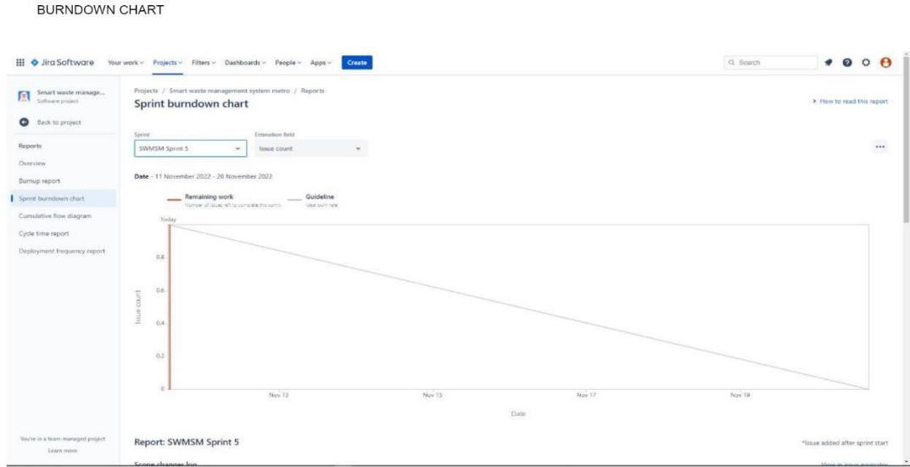

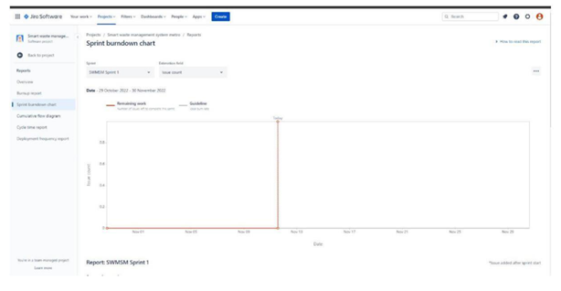

**CODING & SOLUľIONING (Explain the featuíes added in the píoject along with code)**

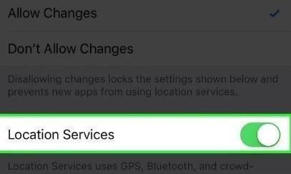

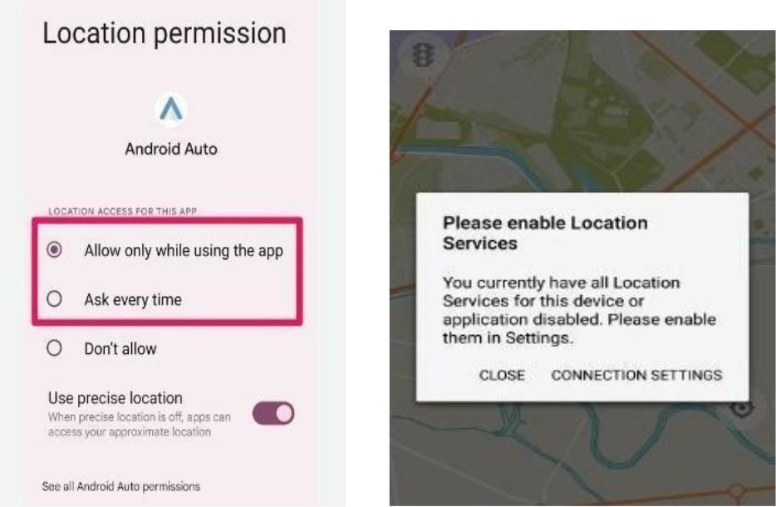

**DATABASE SCHEMA:**

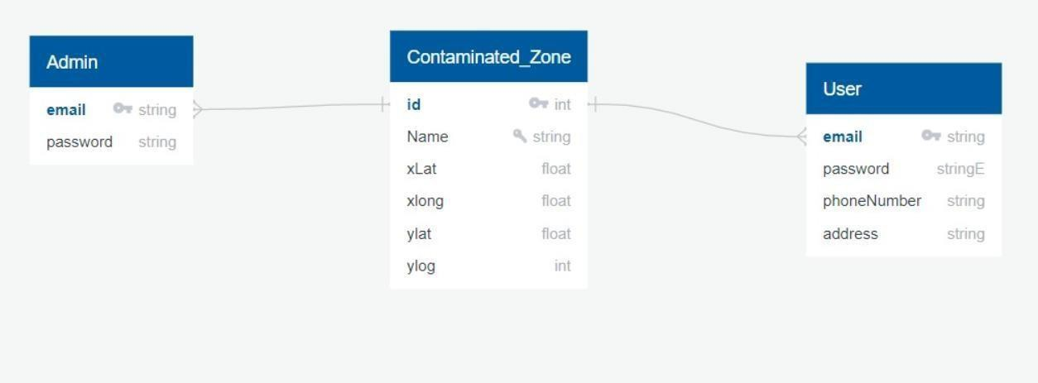

**TEST CASES:**

1. Login button click with wrong credentials entered.
2. Signup with already registered mail ID.
3. Signup with wrong form data entered.
4. Entering home page with logged out session.
5. Clicking home page buttons with logged out session.

Invalid data entered in change password page and requested for change in password.

**USER ACCEPTANCE TESTING:**

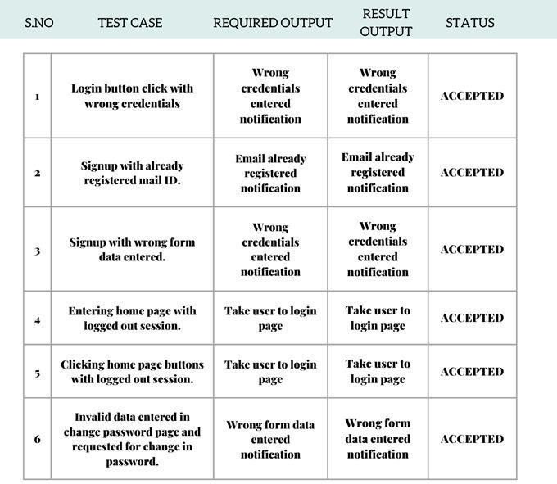

**RESULTS:**

**Admin App:**

Login Page:

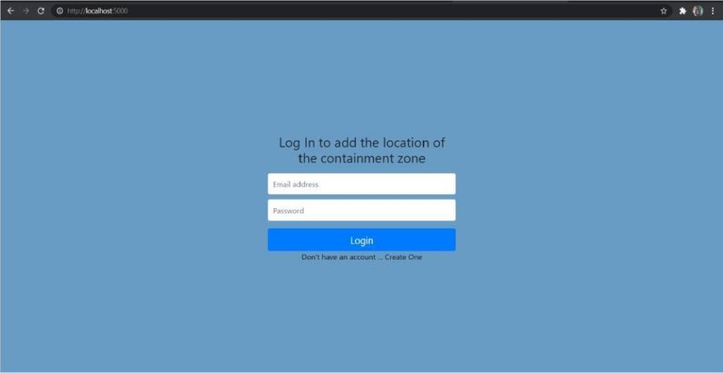

Register page:

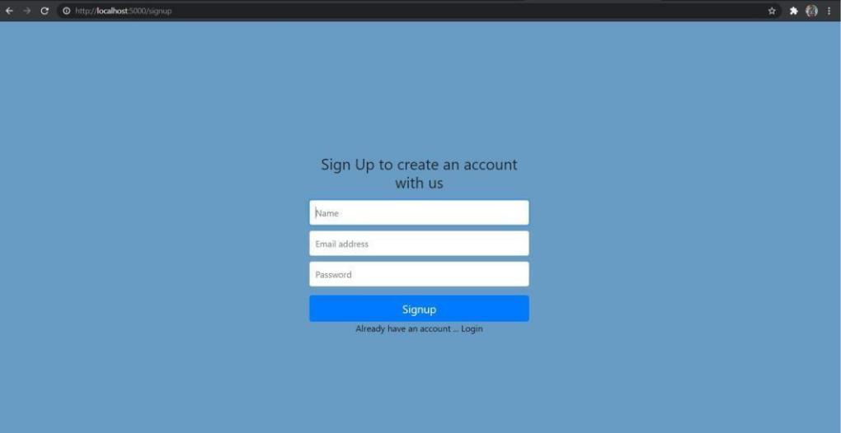

**Home page:**

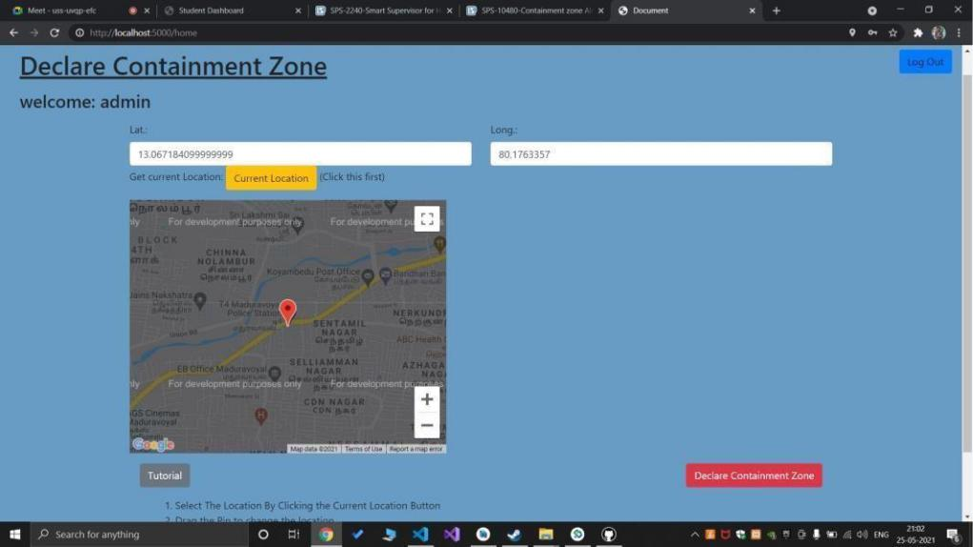

**Location data page:**

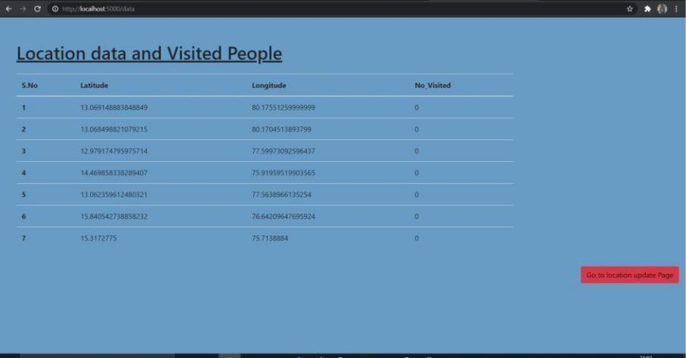

**Current Location:**

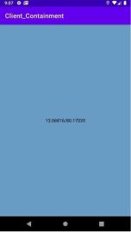

**ADVANTAGES & DISADVANTAGES**

**ADVANTAGES:**

* People can be alerted before entering containment zone.
* Further spread of virus can be reduced considerably.

**DISADVANTAGES:**

* Accuracy of application depends on the number of data given to the application.

• Application’s accuracy is directly proportional to the number of data given to the application

• about the infected patients.

**CONCLUSION:**

Containment Zones are delineated based on Mapping of cases and contacts,

Geographical dispersion of cases and contacts, Area having well demarcated perimeter,

Enforceability of perimeter control.

**Future Scope:**

The application provides an efficient way of showing the identified COVID-19 containment zones to the users in a Google map. With the alarming increase of COVID- 19 affected cases throughout the world, this developed application can be employed as a tool for creating further social awareness among the people. This application further tracks the user's location and checks whether it is present in the list of identified containment zones. It sends separate notification alerts to the user on entering and exiting the containment areas. The developed android application further extracts the IMEI Number of the trespasser in the containment zones which can be useful to the local police to track and identify people who are frequently trespassing the containment zones. Thereby this application identifies the containment zones and highlights the need for taking further precautionary measures for combating COVID-

19. The application has been tested in various locations and has been found to yield accurate results. The application can be further used for many purposes like maritime and forest safety to prevent users from entering restricted areas.

**APPENDIX:**

**Login.HTML:**

**<title>LOGIN</title>**

**<div class="container">**

**<div class="row justify-content-center">**

**<div class="col-lg-5">**

**<div class="card border-2 rounded-lg mt-5">**

**<div class="card-header bg-warning"><h3 class="text-center font-weight-light my-4 text-white ">Login</h3></div>**

**<div class="card-body">**

**<form method="post" action="./code.php">**

**<div class="form-floating mb-3">**

**<input class="form-control" name="email" type="email" placeholder="name@example.com" />**

**<label for="inputEmail">User Name</label>**

**</div>**

**<div class="form-floating mb-3">**

**<input class="form-control" name="password" type="password" placeholder="Password" />**

**<label for="inputPassword">Password</label>**

**</div>**

**<div class="d-flex align-items-center justify-content-between mt-4 mb-0">**

**<button><a href="https://www.ibm.com/in-en">SIGN IN</button></a>**

**</div>**

**</form>**

**</div>**

**</div>**

**</div>**

**</div>**

**</div>**

**Register.HTML:**

**<title>REGISTER</title>**

**<div class="container">**

**<div class="row justify-content-center">**

**<div class="col-lg-7">**

**<div class="card shadow-lg border-0 rounded-lg mt-5">**

**<div class="card-header bg-warning"><h3 class="text-center font-weight-light my-4">Create Account</h3></div>**

**<div class="card-body">**

**<form method="post" action="./regcode.php">**

**<div class="row mb-3">**

**<div class="col-md-6">**

**<div class="form-floating mb-3 mb-md-0">**

**<input class="form-control" name="firstname" required type="text" placeholder="Enter your first name" />**

**<label for="inputFirstName">First name</label>**

**</div>**

**</div>**

**<div class="col-md-6">**

**<div class="form-floating">**

**<input class="form-control" name="lastname" required type="text" placeholder="Enter your last name" />**

**<label for="inputLastName">Last name</label>**

**</div>**

**</div>**

**</div>**

**<div class="form-floating mb-3">**

**<input class="form-control" name="email" required type="email" placeholder="name@example.com" />**

**<label for="inputEmail">Email address</label>**

**</div>**

**<div class="row mb-3">**

**<div class="col-md-6">**

**<div class="form-floating mb-3 mb-md-0">**

**<input class="form-control" name="password" required type="password" placeholder="Create a password" />**

**<label for="inputPassword">Password</label>**

**</div>**

**</div>**

**<div class="col-md-6">**

**<div class="form-floating mb-3 mb-md-0">**

**<input class="form-control" name="passwordc" required type="password" placeholder="Confirm password" />**

**<label for="inputPasswordConfirm">Confirm Password</label>**

**</div>**

**</div>**

**</div>**

**<div class="mt-4 mb-0">**

**<button><a href="https://www.ibm.com/docs/en/i/7.1?topic=solutions-welcome-page-v11">Register</button></a>**

**<br>**

**<br>**

**<button><a href="https://www.google.com/account/about/">GOOGLE</button><br>**

**<button><a href="https://www.facebook.com/">FACEBOOK</a></button><br>**

**<button><a href="https://account.microsoft.com/account?lang=en-us">MICROSOFT ACCOUNT</a></button>**

**</div>**

**</form>**

**</div>**

**</div>**

**</div>**

**</div>**

**</div>**

**Github Account:**

<https://github.com/IBM-EPBL/IBM-Project-34701-1660272455>

**Demo video link:**

[**https://drive.google.com/file/d/1ZizgqPETIrP3UVWTdykY9Y8teAkoH1eu/view?usp=share_link**](https://drive.google.com/file/d/1ZizgqPETIrP3UVWTdykY9Y8teAkoH1eu/view?usp=share_link)